IRUS item types policy 2018

Background
IRUS-UK is a national aggregation service which contains details of all content downloaded from participating UK institutional repositories (IRs). It provides COUNTER-conformant usage statistics covering all item types within repositories. The IRUS-UK service began in 2012 and initially used the list of item types that the PIRUS2 (Publishers and Institutional Repositories) project worked with, as IRUS-UK had lead directly from PIRUS2. However, it was felt that research into use of item types in regular use should be undertaken to ascertain whether this was still the best approach. This work sought to compare existing policies, practices and guidelines concerning the use of item types by institutional repositories (IRs) in order to support a decision around the item types IRUS-UK would use. This was an important area for the service in being able to offer support to its participating institutional repositories (IRs), including for any cross-repository comparisons.
The research indicated a lack of standardisation in the use of item types when looking across all UK repositories. Reasons for this included: where individual IRs have developed their own lists of item types, or where default lists of item types depend on a chosen software platform. The IRUS-UK team took a decision to define a list of item types for use by IRUS-UK, mapping all IR item types in use to a defined list. Item types originating from repositories are stored with potential for re-mapping later should the need arise. This was a pragmatic decision to offer a working solution and the intention was to monitor, review and revise as necessary.
Following development of IRUS item types version 1.1 updates were made on the following dates:
December 2012, Version 1.1; January 2013, Version 2.0; August 2014, Version 3.1; and October 2014, Version 3.3
The final 25 (in version 3.3) were reduced from over 700 item types, that were identified in use in repositories but many of which were very similar. This was all achieved with feedback from the IRUS Community Advisory Group (CAG). For full details of the initial research undertaken on item types, please see ‘IRUS item type report v3.3’ for a detailed breakdown of the methodology used, and the many UK and international policies that were reviewed and detailed appendices of all their guidelines https://irus.jisc.ac.uk/documents/IRUS_item_type_report_v3.3.pdf.

Item types policy 2018 v5
The most recent change made to the IRUS item types policy, was in 2015 affecting one item type. There was a decision to remove the item type ‘Journal’ because the instances where it was used were not of journals, but rather the image from the front page of a journal. These were then remapped as ‘Image’.
Therefore the 25 IRUS item types in use, since 2015 and in this 2018 v5 policy, are:
Art/Design Item; Article; Audio; Book; Book Section; Conference Papers /Posters; Conference Proceedings; Conference or Workshop Item – Other; Dataset; Exam Paper; Image; Learning Object; Moving Image; Music/Musical Composition; Other; Patent; Performance; Preprint; Report; Show/Exhibition; Text; Thesis or Dissertation; Unknown; Website; Working Paper.
With relatively few changes made over time, the approach taken appears to function well in practice and to be appropriate. This approach has been effectively utilised through the international pilot projects underway in Australia, New Zealand and the US, indicating this is fit for purpose.
We continue to monitor item types in everyday use, on an ongoing basis through our monthly mapping process, which is described below.

Mapping item types process
The original item types, that come from the participating repositories, are stored, so it is possible to map these to the 25 agreed IRUS item types whilst keeping the original data.
Manual mapping of item types is done monthly. We harvest data into our database and then compare it with the ‘IRUS-UK itemtype mappings’ list. You can view this table in the IRUS-UK portal: ‘IRUS-UK Itemtype mappings’ in the ‘Metadata Views’ tab.
This shows the comparison of the 25 IRUS-UK item types and the many repository item types that we have harvested. Below is a snapshot of items previously mapped to IRUS-UK’s first item type: ‘Art/Design Item’, along with the item types harvested from the original repository and the number of items in each case (see image below):
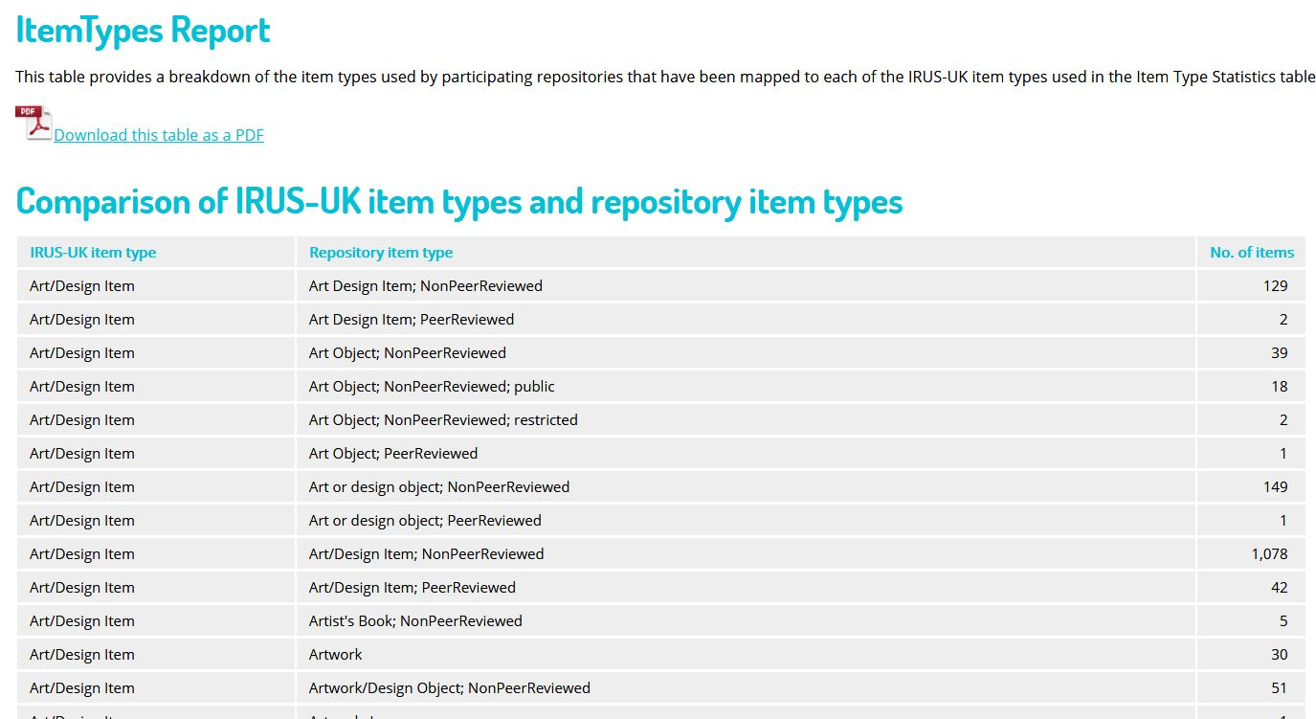
We look at all the data, but primarily we focus on items that have come, into the ‘Other’ IRUS-UK item type. Here is a small snapshot (see image below):
After checking for the source ID in our database, we can find the URL for each item in its hosting repository. Then we can map this to one of our 25 IRUS-UK item types. We select the most appropriate IRUS-UK item type, whereas the host repository may have selected multiple item types (see image above).
All items are mapped, including ones that fall into the two non-specific item types ‘Unknown’ and ‘Other’ explained below.
‘Unknown’: although we try to map to IRUS-UK item types as much as possible, we do include an ‘Unknown’ item type, where the content of the item type field has been left blank or labelled as ‘unknown’ by the participating repository or repositories.
‘Other’: here again it may not be possible to map to IRUS-UK item types where the item type of ‘Other’ has been given by the participating repository or repositories. These may relate to multiple item types from one repository or given the exact same item type description by multiple repositories (see image below):

The table below shows the summary of the 25 IRUS-UK item types (in 2018) and the number of individual items from our participating repositories mapped to each of them. This indicates their prevalence and that these item types are all in regular use. You can view this table in the IRUS-UK portal: ‘Itemtype stats’ in the ‘Metastatistics Views’ tab. The image below shows the number of items up to the end of August 2018.
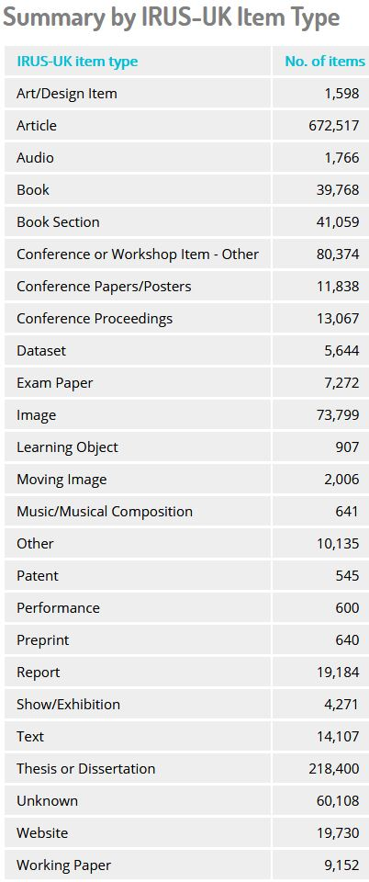

Summary
This policy describes a pragmatic and working solution to managing information about item types where standardisation is currently lacking. However, this process is providing an effective solution in the UK and for pilot initiatives internationally. We continue to examine existing guidelines and evaluate our policy on an ongoing basis and will respond to any changes in the environment as appropriate. We welcome comments from interested parties at: help@jisc.ac.uk.

